Name: Charlen Baloukjy
01/16/2026
Web-Server Exploitation – Pickle Rick CTF (TryHackMe)
- Purpose:
The purpose of this CTF is to exploit a web server and help Pickle Rick find 3 ingredients that will help him craft a potion to return to a human being.
- Methodology:
First, I scanned the target IP address with Nmap to check available open ports.
Using “nmap -sC -sS --top-ports 1000 <target IP>” to scan the top 1000 ports, I was able to identify 2 open ports: 22 for ssh and 80 for http.
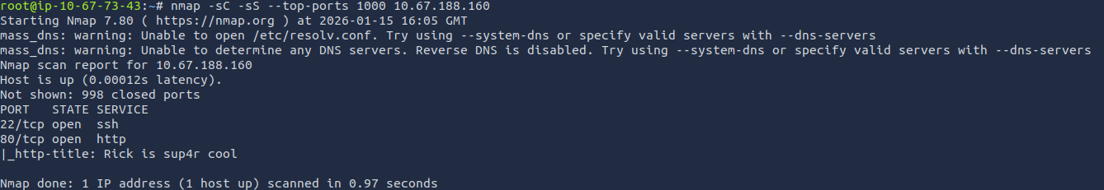
Since the http port was open, I went on FireFox and browsed http://10.67.188.160, which showed me the main page of the web server
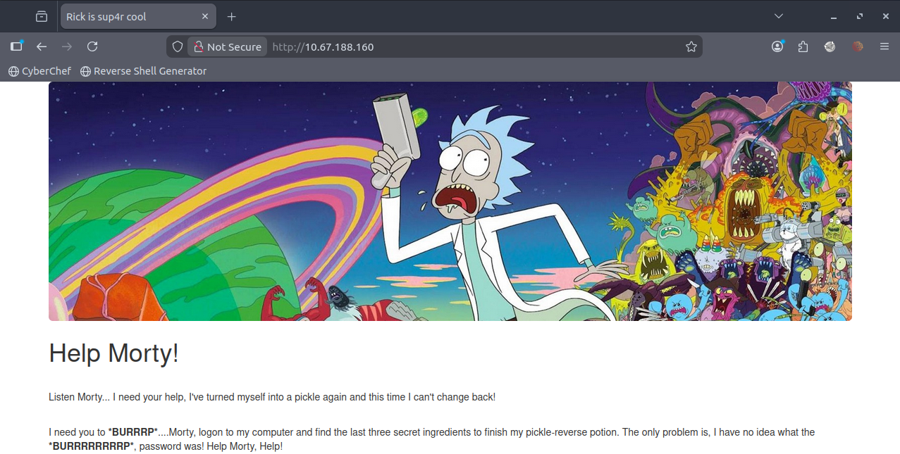
After reading the prompted text, it came to my attention that *BURRRP* and *BURRRRRRRRP* might be hinting at using the BurpSuite tool, so I kept that in mind, in case I needed to use it.
Next, I checked the page source of the main page, where I was able to find the username of Rick, “R1ckRul3s”.
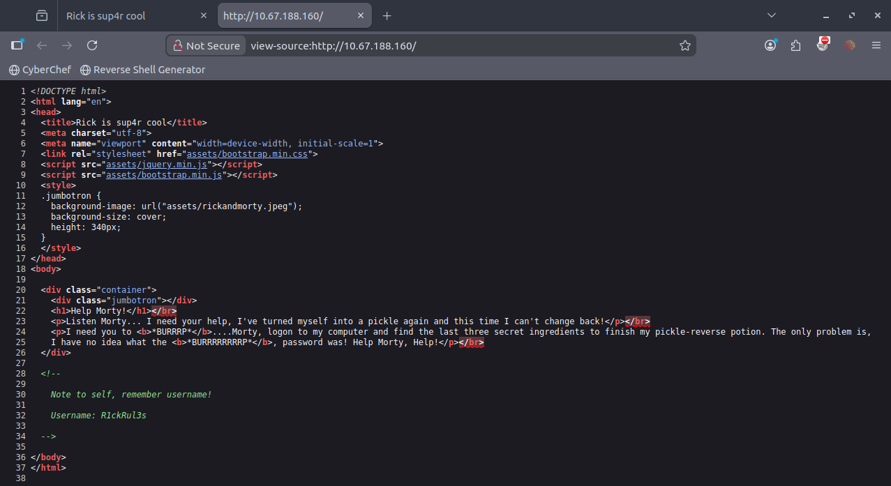
Knowing the username of rick, all that was still needed was the password as well as the login page. So, I decided to use Gobuster to enumerate directories for the web server.
Using the following command: gobuster dir -u <target IP> -w <wordlist for enumeration>
I was only able to identify 2 directories, which weren’t helpful.
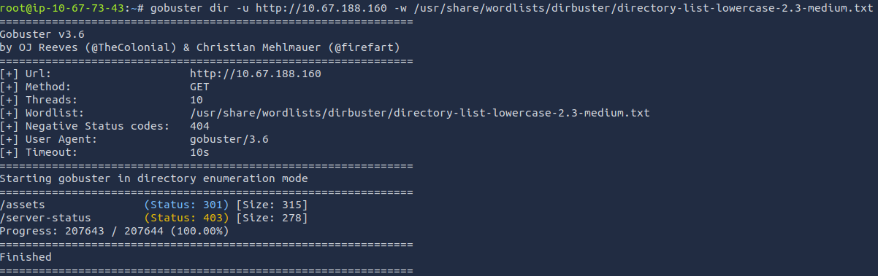
I figured that the directory might be apprehended with an extension, so I reused the command but added an option to look for directories with html, php, and txt extensions.
gobuster dir -u <target IP> -w <wordlist for enumeration> -x html,php,txt
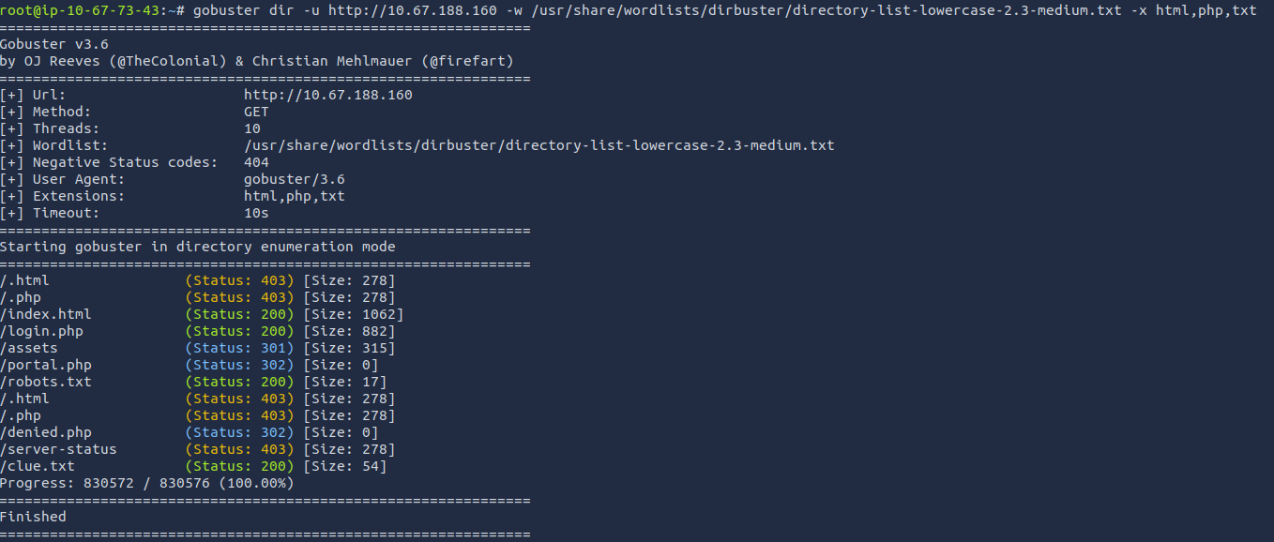
As seen in the picture implied by the status code 200, there are 4 working directories, 3 of which are of interest: /login.php, /robots.txt, and /clue.txt.
Going to the login.php directory showed the login page that we’re looking for.
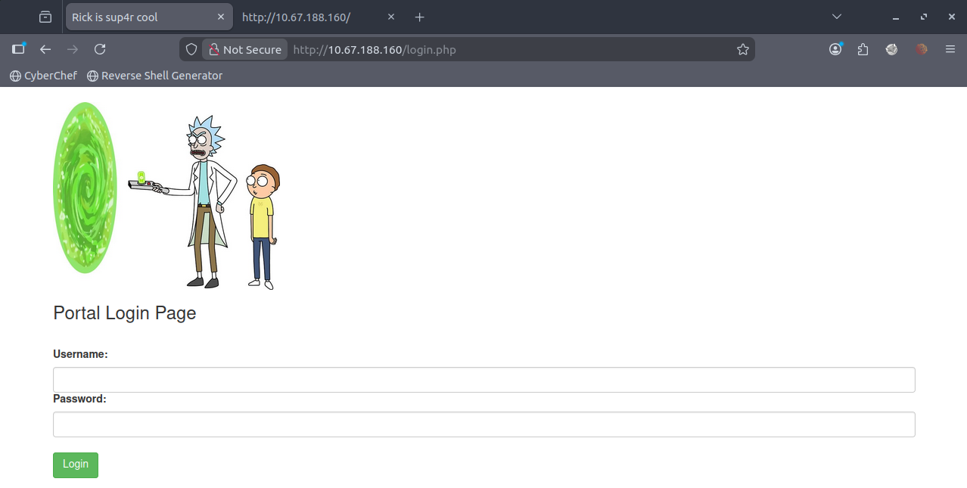
However, a password is still needed to login.

Next, I visited the robots.txt directory, which showed an interesting word.
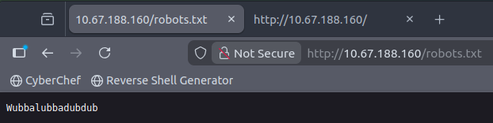
I decided to try that word as the password for the username “R1ckRul3s” … and we’re in!

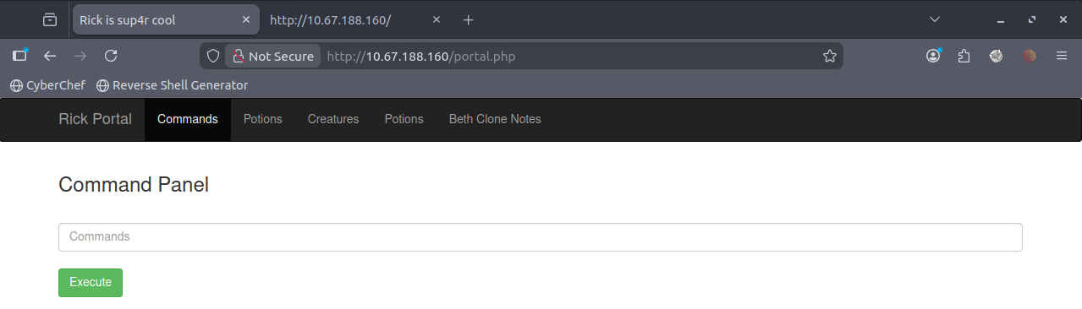
Checking all the headers of this page, I was only able to access the “Commands” header as all the other headers required being the “Real Rick” to view.
So, I tried “ls -al” as a command to list all files and directories. I was able to find the directories and files that gobuster found, in addition to the FIRST ingredient.
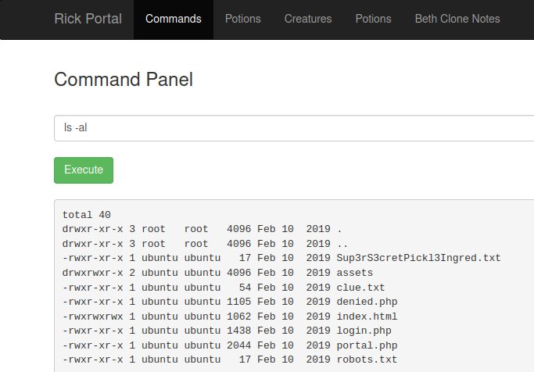
I tried reading the first ingredient file with the “cat” command, but I couldn’t.
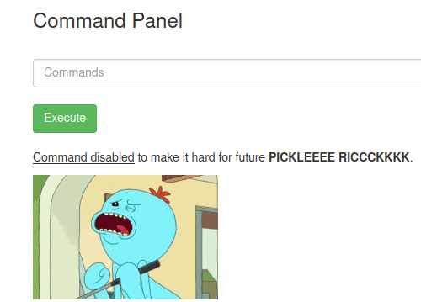
So, I tried another reading command “less”, which worked and gave me the first ingredient.
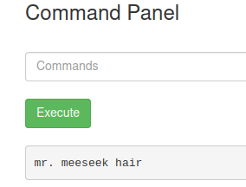
After exploring some commands, I realized that the interface is uncomfortable, so I decided to try and establish a connection on my machine via a reverse shell.
Using the command “which python3” ensured that the web server shell is configured to use python3.
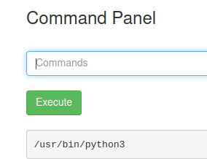
On my machine, I used netcat to listen to connections on port 8888.
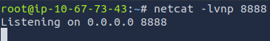
On the target web server, I executed a reverse python3 shell script.
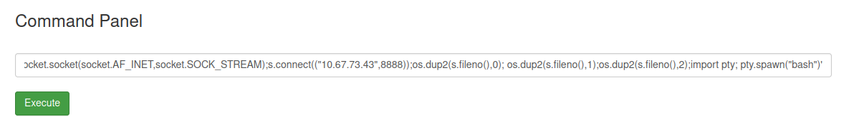
I was able to establish a connection on my machine and so I was in full control of the web server.
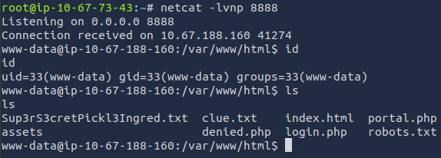
After that, I looked at the clue.txt file, which showed this:
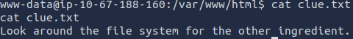
I then went to the home directory where I found a “rick” subdirectory which I went into, using “cd /home/rick”.
There I found the second ingredient.
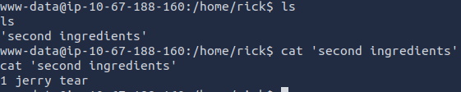
Now for the last ingredient, I thought I’d be able to find it in /etc/passwd, but I didn’t. I tried going into /root, but obviously permission was denied, which meant I needed to try and do privilege escalation.
Using the command “sudo -l” to check my current privileges, it showed that I can execute all commands.
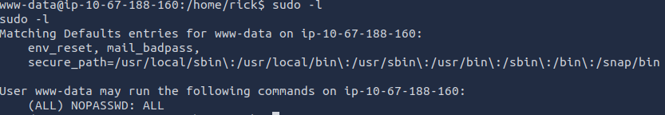
So, I executed the command “sudo bash -i”, which gave me root privileges!
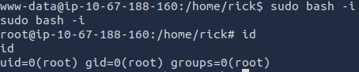
Finally, I was able to navigate to /root where the third and last ingredient was available.
